

Database Systems
( Course Code: CSC270 )

Name: Muhammad Abdullah
Roll No # FA24-BSE-042
Instructor Name: Dr Rubina Adnan

Lab - 4
Lab Task 1:
The HR department needs a report to display the employee number, last name, salary, and salary increased by 15.5% (expressed as a whole number) for each employee. Write a SQL statement for this need. Label the last column as New Salary.
Output:
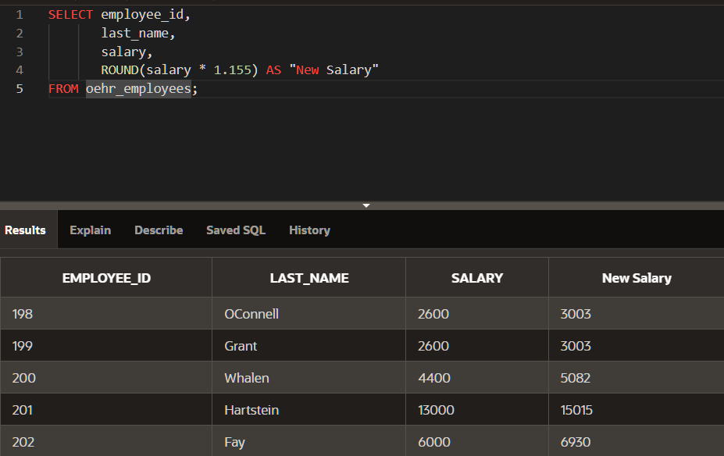
Lab Task 2:
Write a SQL statement that displays the last name (with the first letter in uppercase and all the other letters in lowercase) and the length of the last name for all employees whose name starts with the letters “J”, “A”, or “M”. Give each column an appropriate label. Sort the results by the employees ‘last names. Rewrite the query so that the user is prompted to enter a letter that the last name starts with. For example, if the user enters H (capitalized) when prompted for a letter, then the output should show all employees whose last name starts with the letter H.
Output:
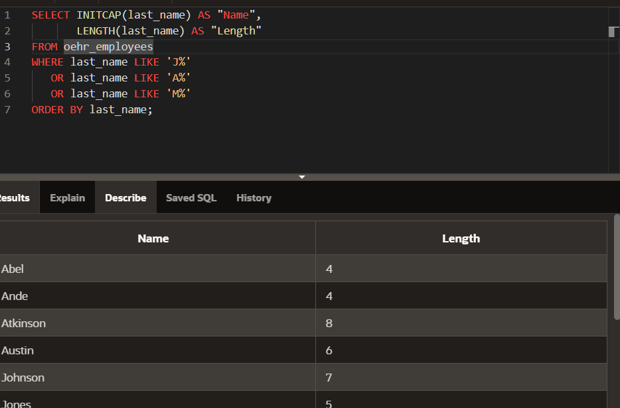
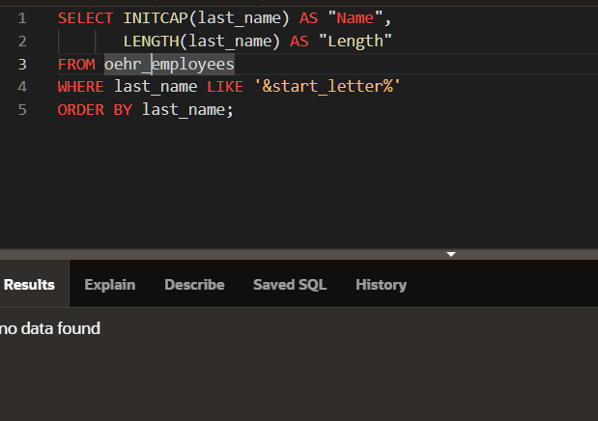

Lab Task 3:
The HR department wants to find the duration of employment for each employee. Write a SQL statement that for each employee, display the last name and calculate the number of months between today and the date on which the employee was hired. Label the column as MONTHS_WORKED. Order your results by the number of months employed. Round the number of months up to the closest whole number.
Output:
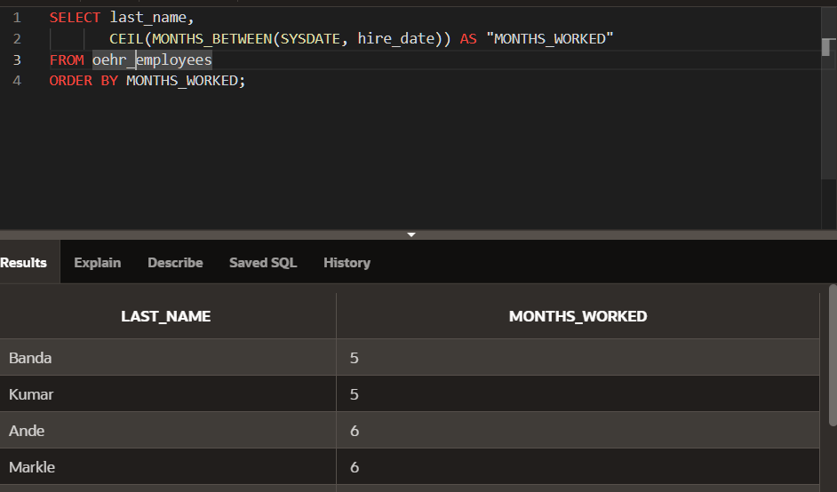

Lab Task 4:
Write a SQL statement that displays the employee’s last names and commission amounts. If an employee does not earn commission, show ― No Commission. Label the column as COMM.
Output:

